Papers written by
Australian Maths Software

REVISION 3
2016

SEMESTER 2

MATHEMATICS
APPLICATIONS
Units 1 & 2

SOLUTIONS

SECTION 1 – Calculator-free
Question 1 (5 marks)

(a)

The 125 grams for $4.90 is the cheaper

(b)
Holly will get $7000 a month next year.

Question 2 (5 marks)
(a)
(b)

(c) cannot be calculated as the matrices are not the same size.

Question 3 (8 marks)
(a) (i) $300 x 4 = $1 200

(ii) $300 x 10 = $3 000
Profit = $3 000 – $900 = $2100
(iii)

(b)

Question 4 (13 marks)
(a) (i)
(ii)
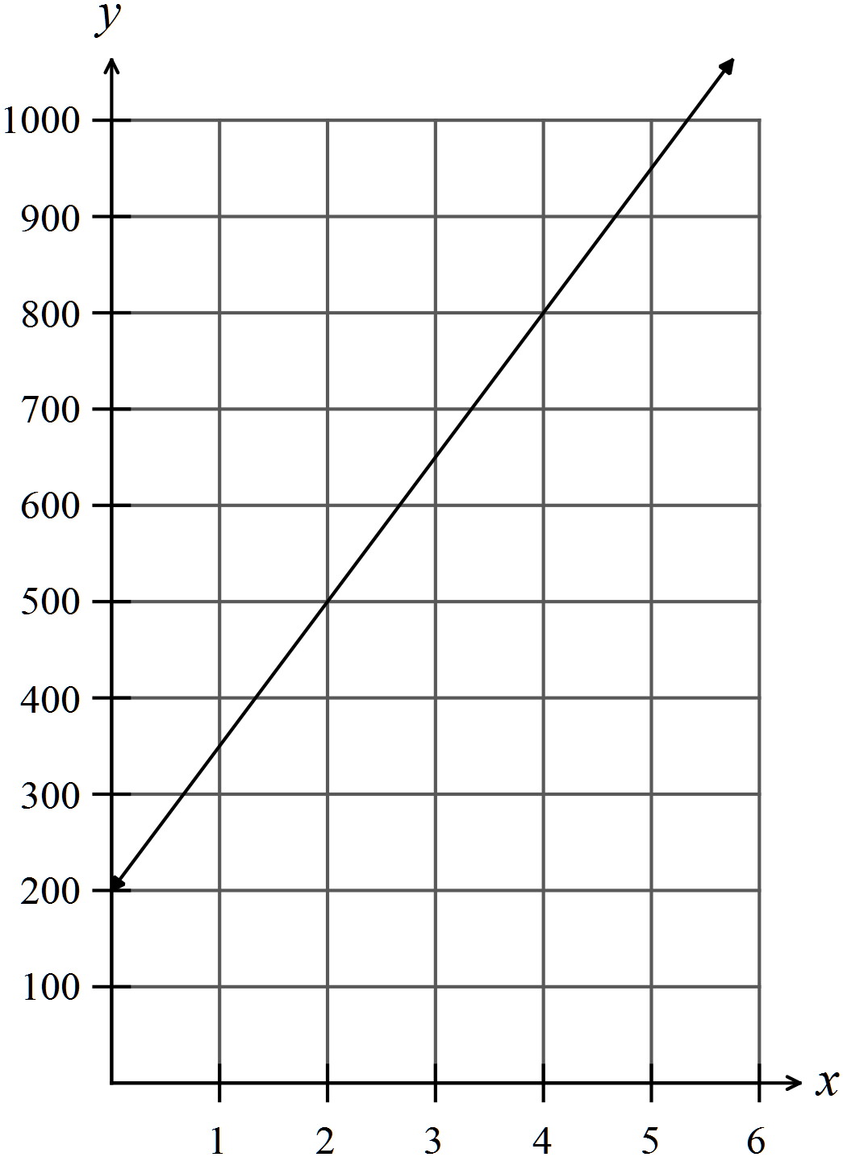
(iii)
(iv)
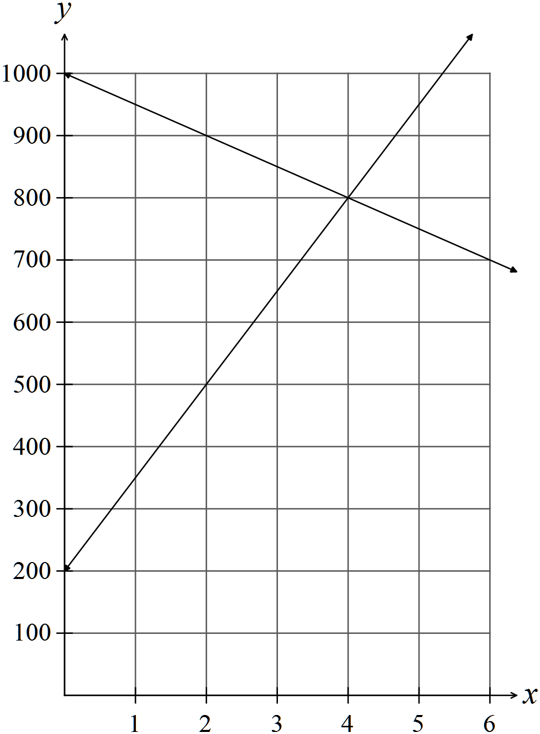
(v) After 4 weeks.

(vi)

(b)

Question 5 (9 marks)

(a)

(b)

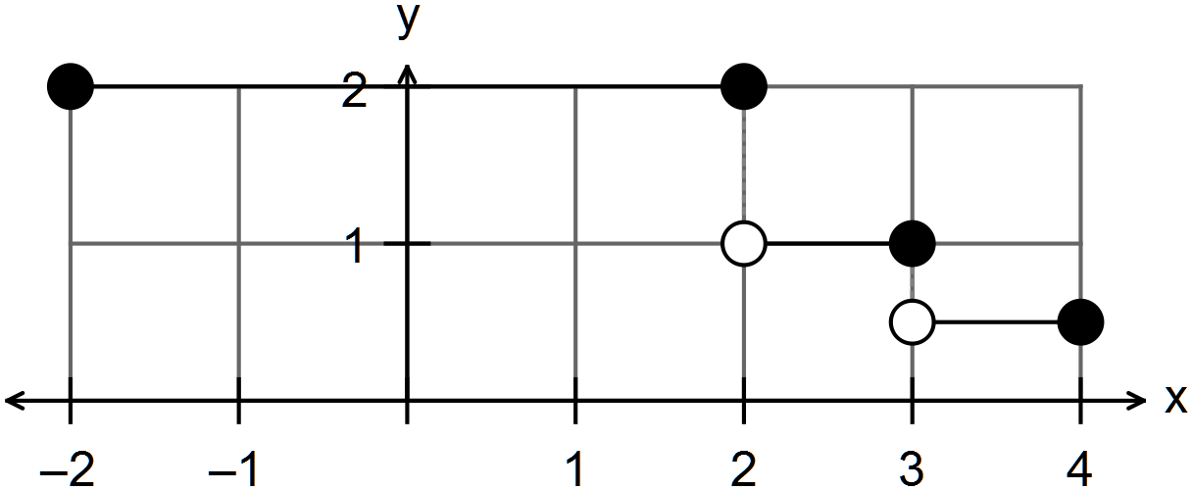
inequalities

Question 6 (12 marks)
(a) (i) “Educational level” is ordinal as you can rank education according to the number of
years.
(ii) The “number of pets in a family” is discrete as the number of pets is a counting
number.

(iii)
1
3
(b) (i)
(ii) 101

(iii) The distribution is very tightly clustered.
The data is skewed to the right with the mode being the minimum score.

END OF SECTION ONE

SECTION 2 – Calculator-assumed
Question 7 (6 marks)
(a)
-1/error

(b) -1/error

(c) Ranking scores (sum of the rows):

P | 5
Q | 2
R | 3
S | 4

The ranking of the teams from first to last is

Question 8 (11 marks)
(a) (i)
(ii) $87.99 x 52 = $4575.48

(iii) $20990 – 52 x $50 = $18 390
(iv) i.e. 12.4% depreciation.

(b) (i)

(ii) Profit $16
Profit % =

Question 9 (11 marks)
(a) (i)

(ii)

(iii)
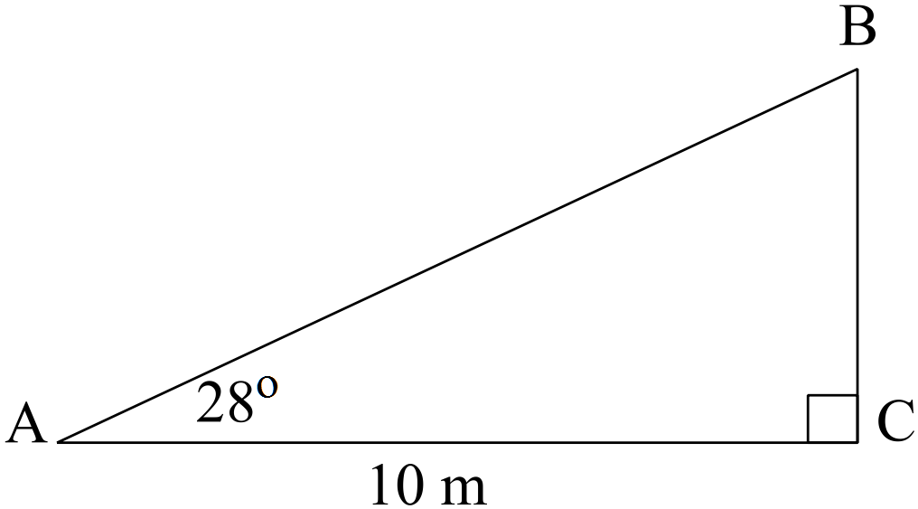

(b)
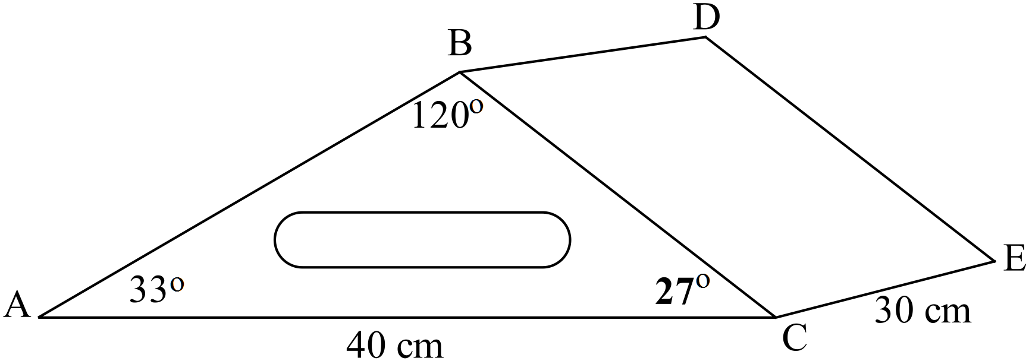
(i)

(ii)
(iii) Volume = area of end x length
Question 10 (9 marks)
(a)
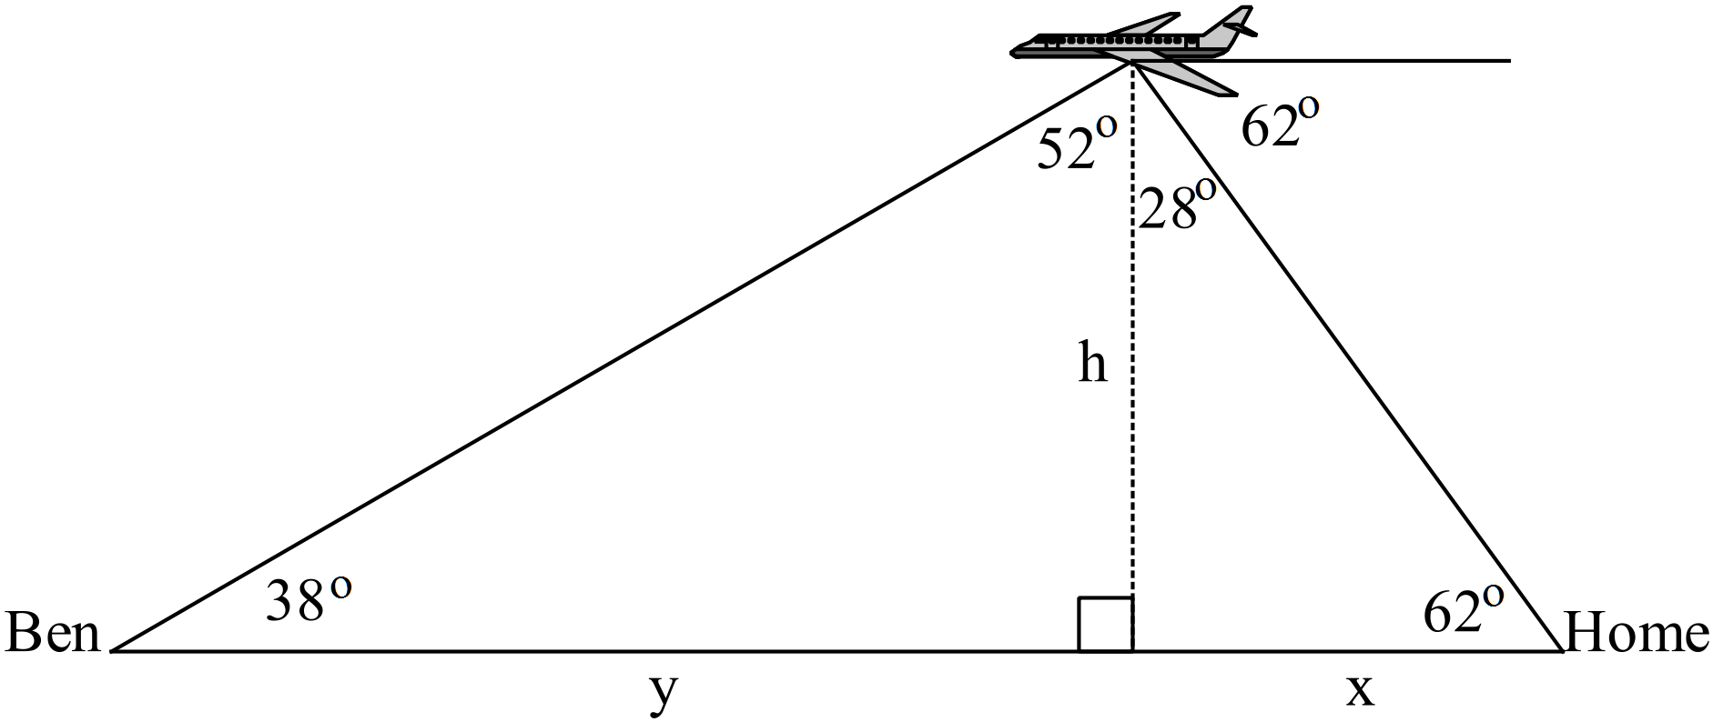

The plane is approximately 3000 metres above the ground.
(b) (i)
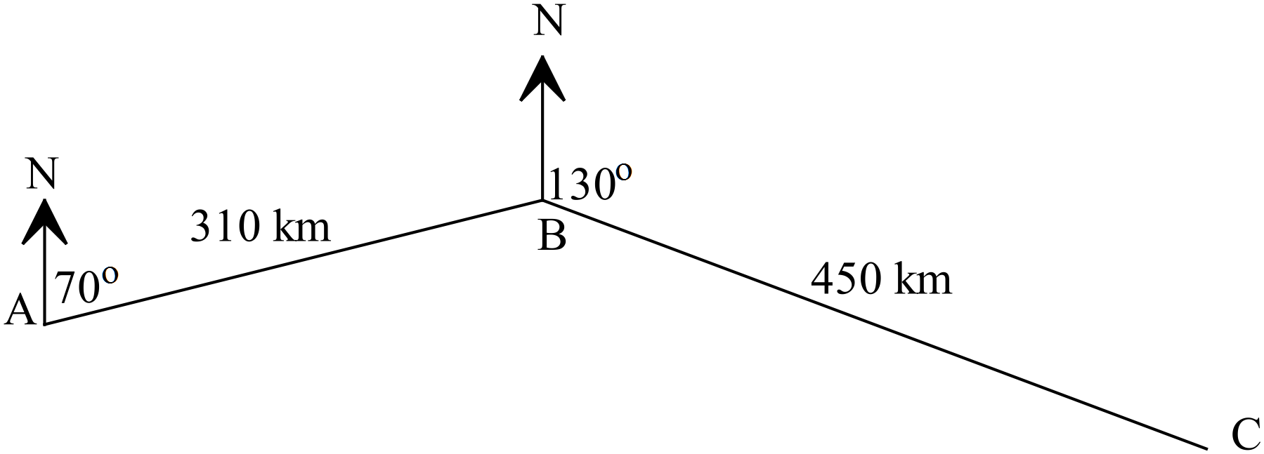

(ii)
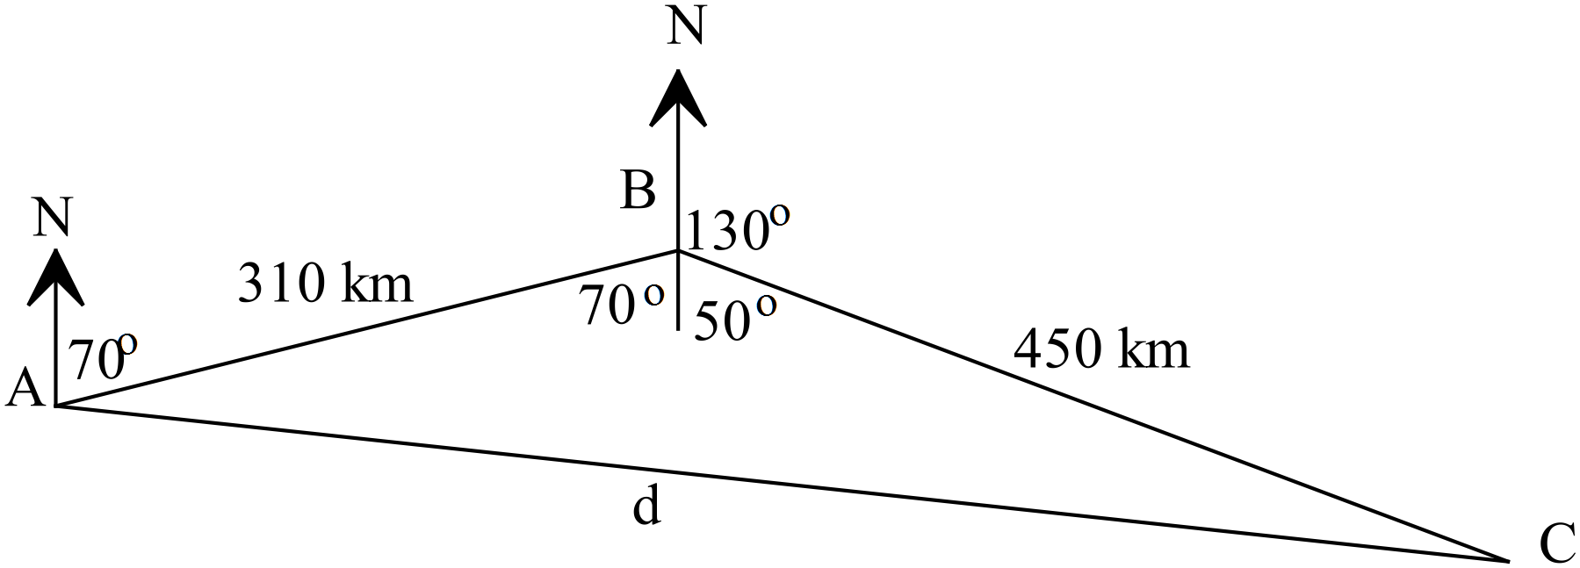

The plane is 662 km from Perth
Question 11 (5 marks)
(a)

The multiplying linear factor is 15.
Weight =

(b)

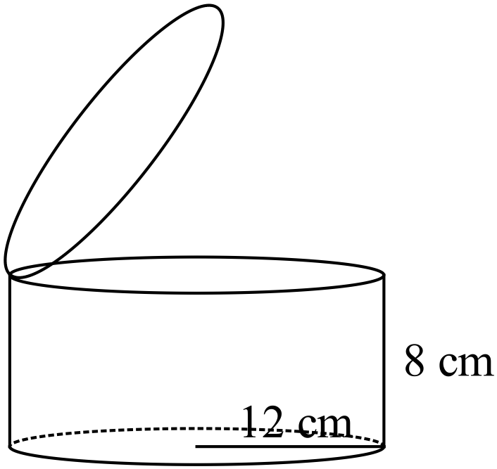

Question 12 (7 marks)
(a)

(b)

Question 13 (8 marks)
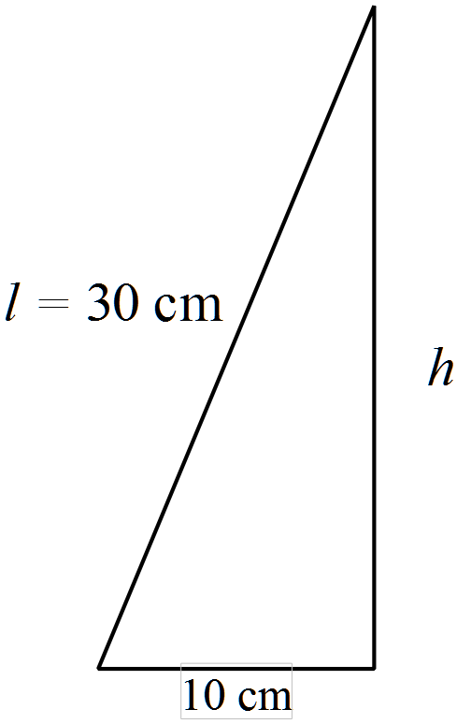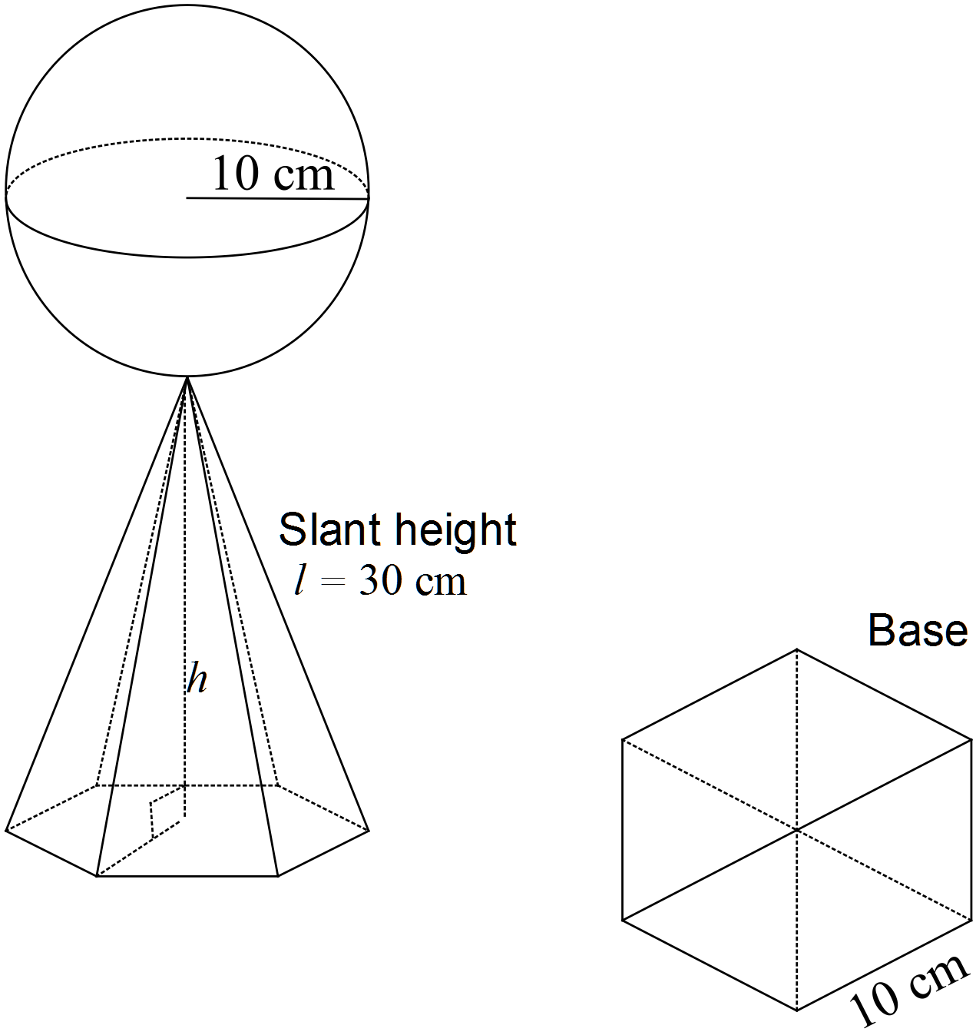
(a)

(b)

(c)

Question 14 (4 marks)
Let x be the price of a dozen eggs.
Let y be the price of a loaf of bread.

Therefore a dozen eggs costs $4 and a loaf of bread costs $2.30

Question 15 (13 marks)
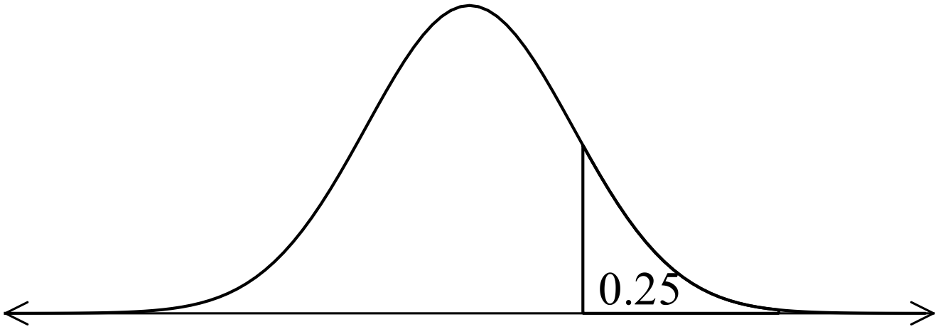 (a) (i) 0.9332
(ii) 0.8413
(iii) 0.6692
(iv) 76

(b) Maths z = 2 70+2(10) = 90%
English z = 0 75%
PE z = -1.96 80%- 1.96 x 15 = 50.6%
Question 16 (17 marks)
(a) (i) Range = 7 – 1 = 6
IQR = 4.5 – 2.5 = 2
(ii) It will change the maximum to 10 as the end point is now 10.
It changes the range from 6 to 9.
(iii) Q₁ changes from 2.5 to 3
IQR changes to 4.5 – 3 =1.5
(iv) The median changes from 4 to 3
(v) Each point will increase by 2 so the range goes from 3 to 9 but remains at 7.
The IQR will remain the same.
All other measures, Q1, Q2, Q3, max, min will increase by 2.
(vi) Set 1
Set 2

Both sets have a median of 4.
Set 1 Range = 7 – 1 = 6 IQR = 4.5 – 2.5 = 2
Set 2 Range = 5 – 1 = 4 IQR = 5 – 2 = 3
The middle 50% in Set 2 are more spread out than the highly clustered middle 50% of
Set 1, especially between Q₂ and Q₃.
The top 50% is the same as the top 25% in Set 2, so the scores are clustered between 4 and 5. The data is skewed to the left. The maximum is the same as Q₃.
There may be outliers at either end of the data in Set 1.

(b)

Question 17 (7 marks)
(a)

(b)
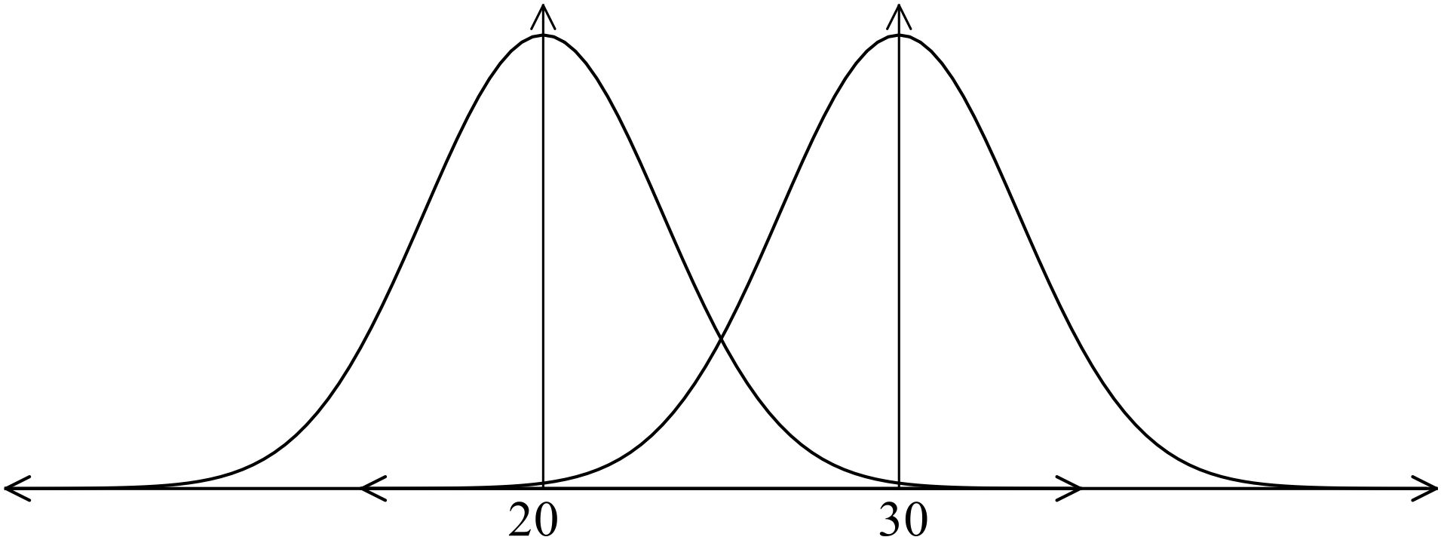

End of solutions

